
AMDOX PROJECT REPORT
to
Chandan Mishra Sir
Amdox Data Science & Analytics
On
Emotion-Aware Productivity and HR Support System
Submitted in partial fulfillment of the requirements for the Internship Certification
Bachelor of Technology
In
Computer Science and Engineering – Data Science
Of
Garden City University

By
Gangothri Devi M
Under the guidance of Chandan Mishra Sir(Internship mentor).

1. Project Title
Emotion-Aware Productivity and HR Support System (AI-Powered Emotion Detector & Task Optimizer)
The title reflects the dual focus of the project:
- Emotion-Aware: The system is designed to recognize and interpret human emotions using AI techniques.
- Productivity: Based on detected emotions, the system recommends tasks that align with the employee’s current mood, thereby improving efficiency.
- HR Support System: It provides actionable insights to Human Resources by tracking emotional trends and alerting them about potential stress or burnout situations.
- Amdox AI-Powered Task Optimizer: This emphasizes that the solution is powered by artificial intelligence and focuses on optimizing task allocation in a workplace environment.
The title is comprehensive, highlighting both the technical foundation (AI, emotion detection) and the practical application (productivity and HR support).

2. Objective
The objective of this project is to design and implement a holistic AI-powered system that integrates emotion detection with workplace task management. The system’s goals can be explained in detail as follows:

a) Detect Employee Emotions
- Text Analysis: Using Natural Language Processing (NLP) models to analyze employee messages, emails, or chat inputs.
- Speech Analysis: Leveraging audio processing techniques (MFCC features, deep learning models) to detect emotions from voice recordings.
- Facial Analysis: Applying computer vision models (CNNs, FER libraries, DeepFace) to identify emotions from facial expressions.
This multimodal approach ensures that emotions are captured accurately across different communication channels.

b) Recommend Tasks Based on Mood
- The system maps emotions to suitable tasks. For example:
  - Joy/Excitement: Assign creative or collaborative tasks.
  - Sadness/Fatigue: Assign routine or less demanding tasks.
  - Anger/Frustration: Assign independent or technical problem-solving tasks.
- This ensures employees work on tasks that match their emotional state, improving productivity and reducing stress.

c) Track Emotional Trends
- The system logs emotions over time for each employee.
- Historical data is analyzed to identify patterns such as prolonged sadness, frequent anger, or consistent neutrality.
- This helps HR understand long-term emotional wellbeing and intervene when necessary.

d) Generate Team Mood Analytics
- Aggregates emotion data across teams.
- Provides visual dashboards showing mood distribution (e.g., percentage of team members feeling stressed vs. motivated).
- Helps managers make informed decisions about workload balancing, team morale, and organizational culture.

e) Alert HR About Stress or Burnout
- If negative emotions (sadness, anger, fear) persist for a set duration, the system automatically generates alerts.
- HR can then take proactive measures such as counseling, workload adjustments, or wellness programs.
- This feature supports employee wellbeing and reduces attrition risks.

f) Enhance Workplace Productivity and Wellbeing
- By aligning tasks with emotions, employees are more engaged and efficient.
- By monitoring emotional health, HR can prevent burnout and foster a supportive environment.
- The system balances organizational goals with employee mental health, creating a sustainable productivity model.

g) Safeguard Privacy
- Employee IDs are anonymized using hashing techniques.
- Data is stored securely, ensuring compliance with ethical and legal standards (e.g., GDPR).
- This builds trust and ensures responsible use of AI in HR contexts.

3. Project Structure
The project is organized into modular components, each serving a distinct purpose. This modular design ensures clarity, scalability, and ease of testing.
Detailed Explanation:
a) Emotion Detection
- Text Emotion Detection: Uses NLP models to classify emotions in written communication.
- Speech Emotion Detection: Extracts audio features (MFCCs, chroma) and applies classifiers to recognize emotions in voice recordings.
- Facial Emotion Detection: Leverages DeepFace or FER libraries with OpenCV to analyze facial expressions.
b) Task Recommendation
- Provides rule-based mapping of emotions to suitable tasks.
- Example: Joy → creative tasks, Sadness → routine tasks, Anger → independent tasks, Neutral → administrative tasks.
c) Mood Tracking
- Logs emotions with timestamps, employee identifiers, and sources (text, speech, face).
- Enables historical analysis of emotional trends for individuals and teams.
d) Stress Alerts
- Monitors recent emotion logs for sustained negative emotions.
- Generates alerts to HR when thresholds are exceeded, helping detect burnout risks.
e) Team Analytics
- Aggregates emotion data across teams.
- Provides visual dashboards showing collective mood distribution and trends.
f) Privacy Module
- Ensures employee privacy by anonymizing identifiers using hashing techniques.
- Maintains compliance with data protection standards.
g) FastAPI Backend
- Provides RESTful API endpoints to integrate all modules.
- Allows external systems or dashboards to access emotion detection, task recommendations, stress alerts, and analytics seamlessly.

4. Technologies Used
The project leverages a combination of programming languages, frameworks, libraries, visualization tools, databases, and deployment platforms to achieve its objectives.
- Programming Language
• Python 3.8+ is chosen for its simplicity, readability, and extensive ecosystem of libraries for data science, machine learning, and application development.
- Frameworks
• FastAPI: A modern, high-performance web framework used to build RESTful APIs. It supports asynchronous operations and automatic documentation.
• Uvicorn: An ASGI server that runs FastAPI applications efficiently, enabling real-time performance and scalability.
- Libraries
• Transformers: Provides pretrained NLP models for text emotion classification.
• Torch and TensorFlow: Deep learning frameworks used for training and inference of emotion detection models.
• Pandas: Handles data manipulation, mood logging, and analytics.
• Matplotlib and Seaborn: Generate visualizations of mood trends and team analytics.
• OpenCV: Performs image preprocessing and facial emotion detection.
• DeepFace and FER: Specialized libraries for facial emotion recognition.
• Librosa: Extracts audio features such as MFCCs for speech emotion recognition.
- Visualization Tools
• Matplotlib and Seaborn: Used for static plots and charts to represent emotion distributions.
• Streamlit or Dash: Provide interactive dashboards for HR teams to monitor employee wellbeing and team mood analytics.
- Database/Storage
• CSV files: Used in the prototype phase for simple logging of emotions.
• SQLite or PostgreSQL: Recommended for scalable, production-ready storage solutions with support for concurrent access and advanced queries.
- Deployment Platforms
• Heroku: Enables quick deployment of FastAPI applications to the cloud.
• Streamlit Cloud: Hosts interactive dashboards for easy access by HR teams.
• Docker: Containerizes the application, ensuring portability, consistency, and simplified deployment across environments.

5. Core Features Implemented
The system integrates multiple functionalities to ensure robustness, usability, and completeness. Each feature is designed to address a specific challenge in workplace emotion analysis and productivity support.
5.1 Emotion Detection from Text, Speech, and Facial Inputs
• Text Emotion Detection: Uses NLP models (RoBERTa/BERT) to classify emotions in employee messages, emails, or chat inputs.
• Speech Emotion Detection: Extracts audio features such as MFCCs, chroma, and spectral features using Librosa, then applies classifiers to detect emotions in voice recordings.
• Facial Emotion Detection: Leverages computer vision models (FER, DeepFace, CNNs) with OpenCV to analyze facial expressions and identify emotions in real time.
5.2 Task Recommendation Based on Detected Emotions
• A rule-based engine maps emotions to suitable tasks.
• Joy/Excitement → Creative or collaborative assignments.
• Sadness/Fatigue → Routine or less demanding tasks.
• Anger/Frustration → Independent or technical problem-solving tasks.
• Neutral → Administrative or organizational tasks.
5.3 Mood Logging for Historical Tracking
• Every emotion detection event is logged with timestamp, anonymized employee ID, emotion label, source (text, speech, face), and team.
• Historical logs allow HR to track emotional trends over time and identify long-term patterns.
5.4 Stress Alert System to Notify HR About Burnout Risks
• Monitors recent emotion logs for sustained negative emotions (sadness, anger, fear).
• If thresholds are exceeded (e.g., repeated negative emotions over multiple entries), the system generates alerts.
• Alerts can be integrated with HR communication channels such as email or Slack.
5.5 Team Mood Analytics with Visual Dashboards
• Aggregates emotion data across teams to provide collective insights.
• Generates stacked bar charts, line graphs, and heatmaps showing mood distribution and trends.
• Helps managers assess team morale, workload balance, and productivity.
5.6 Data Privacy Through Anonymization
• Employee identifiers are anonymized using hashing techniques (e.g., SHA-256).
• Ensures compliance with data protection standards such as GDPR.
• Builds trust by safeguarding sensitive employee information.
5.7 API Endpoints for Modular Integration
• FastAPI endpoints expose each module’s functionality.
• External systems or dashboards can access emotion detection, task recommendations, stress alerts, and analytics.
• Provides scalability and modularity for enterprise integration.

6. Architecture & Workflow
The system follows a layered architecture, ensuring modularity and clarity in data flow. Each stage is designed to process, analyze, and deliver results efficiently.
6.1 Input Layer
• Function: Accepts employee input in the form of text, speech, or facial data.
• Sources: Chat messages, audio recordings, or webcam images/video frames.
• Flexibility: Supports multiple modalities to capture emotions comprehensively.
6.2 Preprocessing Layer
• Function: Cleans and normalizes raw input for consistency.
• Tasks: – Text cleaning (lowercasing, removing special characters, tokenization). – Audio preprocessing (MFCC extraction, chroma features, spectral contrast). – Image preprocessing (resizing, grayscale conversion, normalization).
• Outcome: Standardized input ready for emotion detection models.
6.3 Emotion Detection Models
• NLP (RoBERTa/BERT) for text: Pretrained transformer models classify emotions with high accuracy.
• CNN/FER for facial images: Convolutional Neural Networks or FER libraries detect emotions from facial expressions.
• Audio classifiers for speech: Machine learning models classify emotions based on extracted audio features.
6.4 Task Recommendation Engine
• Function: Maps detected emotions to suitable tasks using rule-based logic.
• Outcome: Employees are assigned tasks that align with their emotional state, improving productivity and reducing stress.
6.5 Mood Logger
• Function: Stores emotion data with timestamps, anonymized employee IDs, and sources.
• Outcome: Enables historical tracking and supports analytics modules for long-term insights.
6.6 Stress Alert System
• Function: Evaluates recent mood logs for negative trends.
• Process: Sliding window checks proportion of negative emotions over time.
• Outcome: Generates alerts for HR to intervene early and prevent burnout.
6.7 Analytics Dashboard
• Function: Visualizes team and individual mood distributions.
• Tools: Matplotlib, Seaborn, Streamlit/Dash for interactive dashboards.
• Outcome: Provides HR and managers with actionable insights into team morale and productivity.
6.8 API Layer
• Function: FastAPI endpoints expose system functionality to frontend or HR systems.
• Features: RESTful endpoints for emotion detection, task recommendation, stress alerts, and analytics.
• Outcome: Ensures modular integration, scalability, and easy deployment in enterprise environments.

7. API Endpoints
The system provides RESTful API endpoints built with FastAPI to enable modular integration and external access to all functionalities.
Detailed Explanation:
- GET / • Root endpoint that confirms the API is running. • Returns a simple status message (e.g., “API is live”).
- POST /detect-text-emotion/ • Accepts text input from the user. • Uses the NLP emotion detection model (RoBERTa/BERT) to classify emotions. • Returns the detected emotion label along with confidence scores.
- POST /recommend-task/ • Accepts an emotion label as input. • Provides task recommendations mapped to the given emotion. • Ensures employees are assigned tasks that align with their emotional state.
- GET /check-stress/ • Evaluates recent mood logs for an employee. • Returns stress alert status if negative emotions persist beyond a threshold. • Helps HR identify burnout risks early.
- GET /anonymize/ • Accepts employee ID as input. • Returns anonymized ID using hashing techniques. • Ensures privacy and compliance with data protection standards.

8. Sample Code Snippets
The following code snippets illustrate the core logic of emotion detection and task recommendation modules.
Detailed Explanation:
- Text Emotion Detection
from transformers import pipeline
emotion_classifier = pipeline("text-classification", model="j-hartmann/emotion-english-distilroberta-base", return_all_scores=True)

def detect_text_emotion(text):
result = emotion_classifier(text)
top_emotion = sorted(result[0], key=lambda x: x['score'], reverse=True)[0]
return top_emotion['label']
• This function uses a pretrained NLP model to classify emotions in text. • The pipeline returns all possible emotions with confidence scores. • The function selects the emotion with the highest score and returns its label.
- Task Recommendation
def recommend_task(emotion):
task_map = {
"joy": ["Creative brainstorming", "Team collaboration"],
"sadness": ["Routine tasks", "Documentation"],
"anger": ["Solo debugging", "Technical fixes"],
"neutral": ["Emails", "Admin work"]
}
return task_map.get(emotion, ["General admin tasks"])
• This function maps emotions to suitable tasks using a rule-based dictionary. • Joy leads to creative or collaborative tasks. • Sadness leads to routine or documentation tasks. • Anger leads to independent technical tasks. • Neutral leads to administrative or email tasks. • If the emotion is not recognized, it defaults to general admin tasks.

9. Deployment Steps
The deployment process ensures that the system can move from a local prototype to a production-ready application accessible to HR teams and employees.
Detailed Explanation:
- Create a Virtual Environment and Install Dependencies
• A virtual environment isolates project dependencies from the system environment.
• Command: python -m venv venv followed by activation (source venv/bin/activate or .\venv\Scripts\activate).
• Install all required packages using: pip install -r requirements.txt.
• Ensures reproducibility and avoids conflicts between libraries.
- Run FastAPI Locally with Uvicorn
• Start the backend server using: uvicorn main:app --reload.
• The --reload flag enables automatic restart when code changes are made.
• Provides a local environment to test endpoints before deployment.
- Test Endpoints via Swagger UI
• FastAPI automatically generates interactive documentation at: http://127.0.0.1:8000/docs.
• HR teams or developers can test API endpoints directly in the browser.
• Ensures correctness of input/output formats and validates functionality.
- Containerize with Docker (Optional)
• Create a Dockerfile to package the application, dependencies, and environment.
• Benefits: Portability, consistency across environments, and simplified deployment.
• Supports orchestration with Kubernetes or Docker Compose for scaling.
- Deploy to Heroku, AWS, or Streamlit Cloud
• Heroku: Quick deployment with a Procfile (web: uvicorn main:app --host 0.0.0.0 --port $PORT).
• AWS (Elastic Beanstalk/EC2): Provides scalability and integration with monitoring tools.
• Streamlit Cloud: Ideal for hosting interactive dashboards linked to the FastAPI backend.
• Ensures the system is accessible to HR teams and employees in real-time.

10. Testing & Validation
Testing and validation are critical to ensure the reliability, accuracy, and usability of the system. Each stage verifies different aspects of functionality.
Detailed Explanation:
- Unit Testing
• Scope: Verified each individual module in isolation.
• Examples: – Text emotion detection returns correct labels. – Task recommendation engine maps emotions to appropriate tasks. – Stress alert system triggers alerts when thresholds are exceeded.
• Outcome: Each function works correctly and handles edge cases.
- Integration Testing
• Scope: Ensured smooth workflow across modules.
• Examples: – Input text → Emotion detection → Task recommendation → Mood logging → Stress alert. – Facial input → Emotion detection → Logging → Analytics dashboard visualization.
• Outcome: End-to-end flow produces consistent and structured outputs.
- Validation
• Scope: Compared model outputs with labeled datasets to confirm accuracy.
• Datasets used: FER2013 (facial emotion recognition), RAVDESS (speech emotion dataset), and text emotion datasets.
• Outcome: Predictions aligned with dataset labels, confirming model reliability.
- User Testing
• Scope: Simulated employee inputs to validate usability and recommendations.
• Examples: – Employees entered text messages, audio samples, or facial images. – System generated emotion labels, recommended tasks, and logged moods.
• Outcome: HR teams confirmed that recommendations were meaningful, dashboards were clear, and alerts were triggered appropriately.

11. Challenges & Solutions
This section outlines key technical and practical challenges encountered during development, along with the solutions implemented to ensure robustness, privacy, and usability.
- Challenge: Diverse emotion datasets with varying formats
• Problem: Text, audio, and facial datasets follow different schemas, label sets, sampling rates, and preprocessing needs, causing inconsistency and integration difficulties.
• Impact: Reduced model performance, complex data pipelines, and higher maintenance overhead.
• Solution: Standardized preprocessing pipelines per modality (text, audio, image) with unified label mapping, consistent normalization, and version-controlled data schemas.
• Outcome: Seamless integration across modalities, improved model reliability, and easier debugging/maintenance.
- Challenge: Real-time performance with large models
• Problem: Transformer and deep CNN models can be computationally heavy, increasing latency for real-time inference.
• Impact: Slow user experience, limited scalability in production environments.
• Solution: Adopted lightweight backbones (DistilRoBERTa for NLP, FER library/efficient CNNs for facial detection), enabled batch inference where feasible, and applied model optimization (quantization/ONNX).
• Outcome: Faster response times with minimal accuracy trade-offs, enabling near real-time interactions.
- Challenge: Ensuring privacy of employee data
• Problem: Handling sensitive identifiers and emotion data raises compliance and trust concerns.
• Impact: Potential privacy risks and barriers to organizational adoption.
• Solution: Implemented anonymization (salted hashing for employee IDs), restricted access controls, encrypted storage, and clear retention policies.
• Outcome: Privacy-preserving analytics with compliance-aligned practices that build organizational trust.
- Challenge: Balancing accuracy with usability
• Problem: Highly complex models can be accurate but opaque; purely rule-based systems are transparent but limited.
• Impact: Either reduced interpretability or reduced relevance of recommendations.
• Solution: Combined rule-based recommendations (for transparency and immediate utility) with ML predictions (for personalization and robustness), plus confidence scores and override options.
• Outcome: Reliable, interpretable outputs that are practical for HR workflows and everyday use.

12. Conclusion
The Emotion-Aware Productivity and HR Support System integrates multimodal emotion detection with task optimization to enhance wellbeing and efficiency at work.
Detailed Explanation:
- The system unifies NLP (text), audio analysis (speech), and computer vision (facial expressions) to detect emotions accurately across communication channels.
- A rule-based recommendation engine aligns tasks with detected emotions, reducing cognitive strain and improving engagement.
- Mood logging, stress alerts, and team analytics provide HR with actionable insights for early intervention and workload balancing.
- The architecture demonstrates how data science and machine learning can operationalize empathy in workplace management.
- Future scope includes integration with wearables for physiological signals, reinforcement learning for adaptive task recommendations, and enterprise-grade deployment with autoscaling and SSO.

Abstract
This project presents an AI-powered system that integrates emotion detection with task optimization to enhance workplace productivity and employee wellbeing. By analyzing text, speech, and facial expressions, the system identifies employee emotions and recommends suitable tasks aligned with their mood. It also tracks emotional trends, generates team mood analytics, and alerts HR about potential stress or burnout. The solution leverages data science techniques, machine learning models, and visualization tools to create a comprehensive productivity and HR support system.

13. References
The following sources, tools, and libraries informed model selection, data handling, and system implementation.
- Hugging Face Transformers and Datasets Documentation
• Reference for pretrained NLP models, pipelines, fine-tuning, and dataset handling.
- Kaggle FER2013 Dataset
• Benchmark dataset for facial emotion recognition and CNN evaluation.
- RAVDESS Speech Emotion Dataset
• Labeled audio samples used for training and validating speech emotion classifiers.
- DeepFace and FER Libraries
• High-level APIs for facial emotion detection, enabling rapid prototyping and benchmarking.
- FastAPI Documentation
• Guidance for building high-performance REST APIs, dependency management, and automatic docs (Swagger/OpenAPI).
- Librosa Audio Analysis Library
• Utilities for audio loading, feature extraction (MFCCs, chroma, spectral), and signal processing workflows.

14. Reference Images (Screenshots):

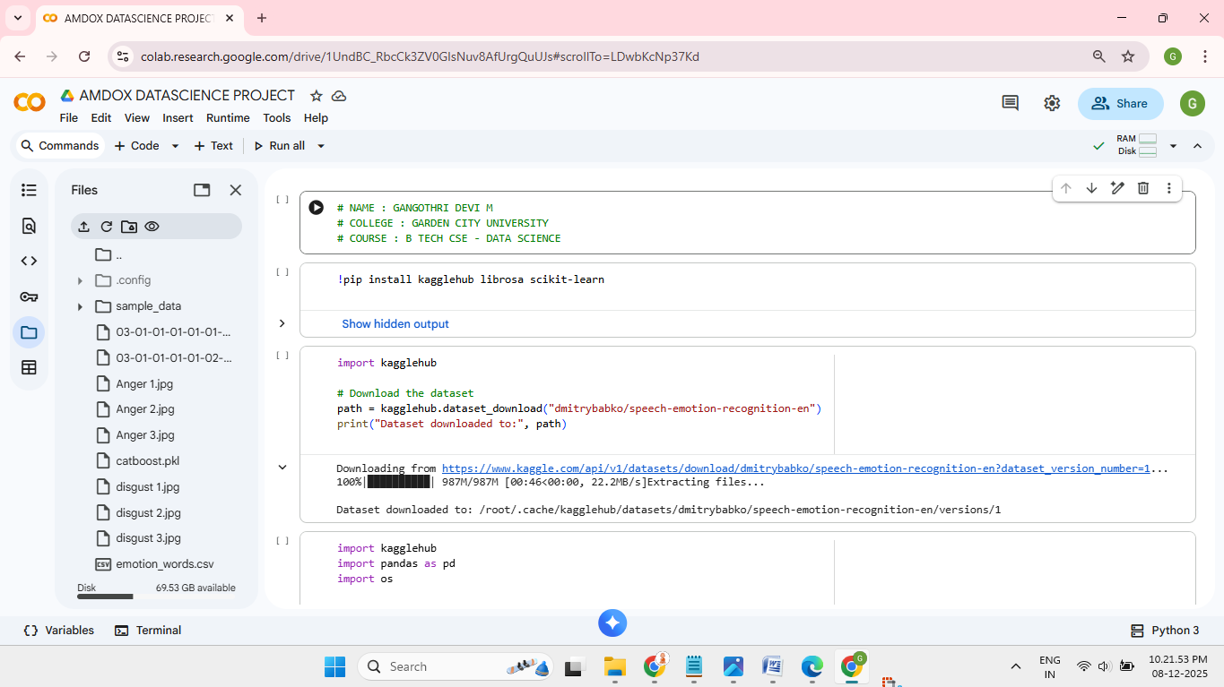

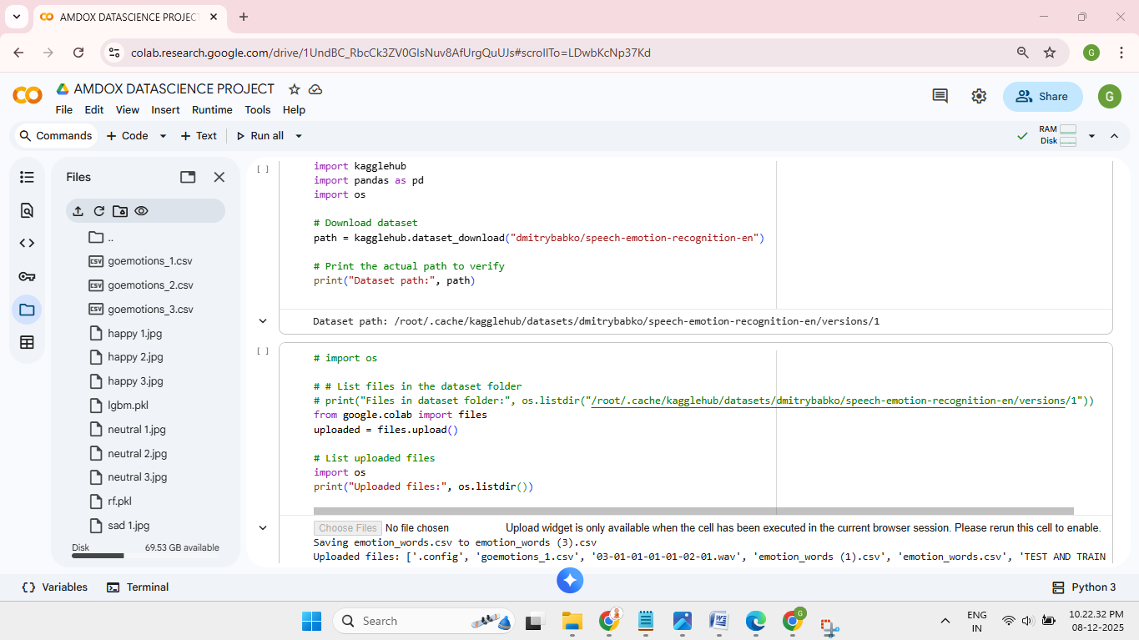
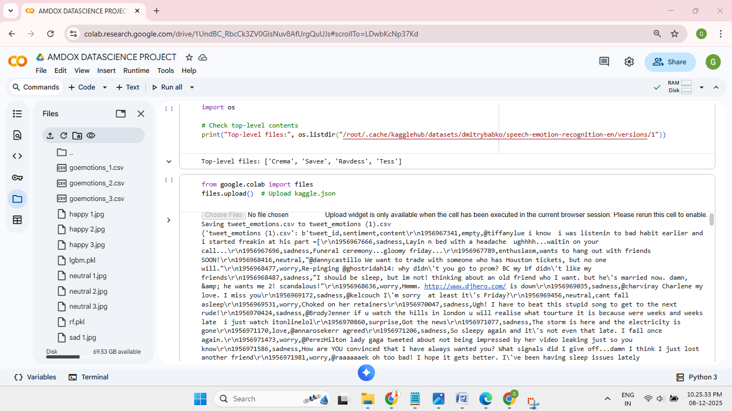
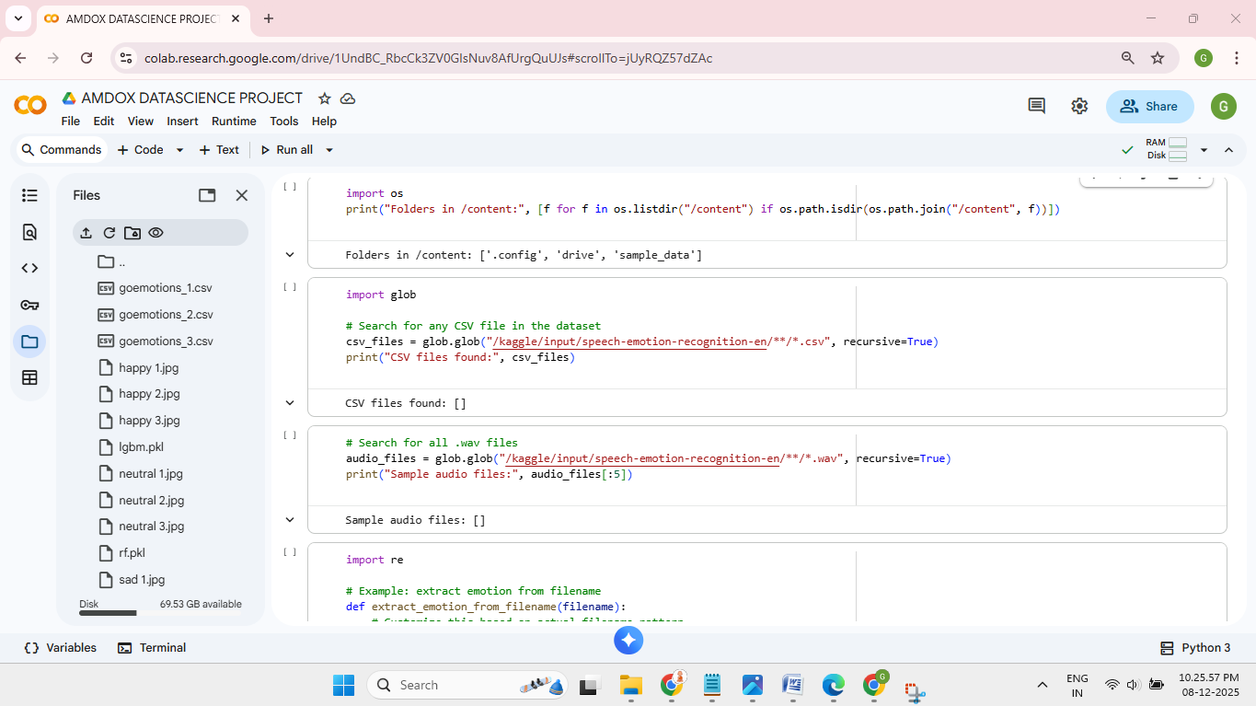
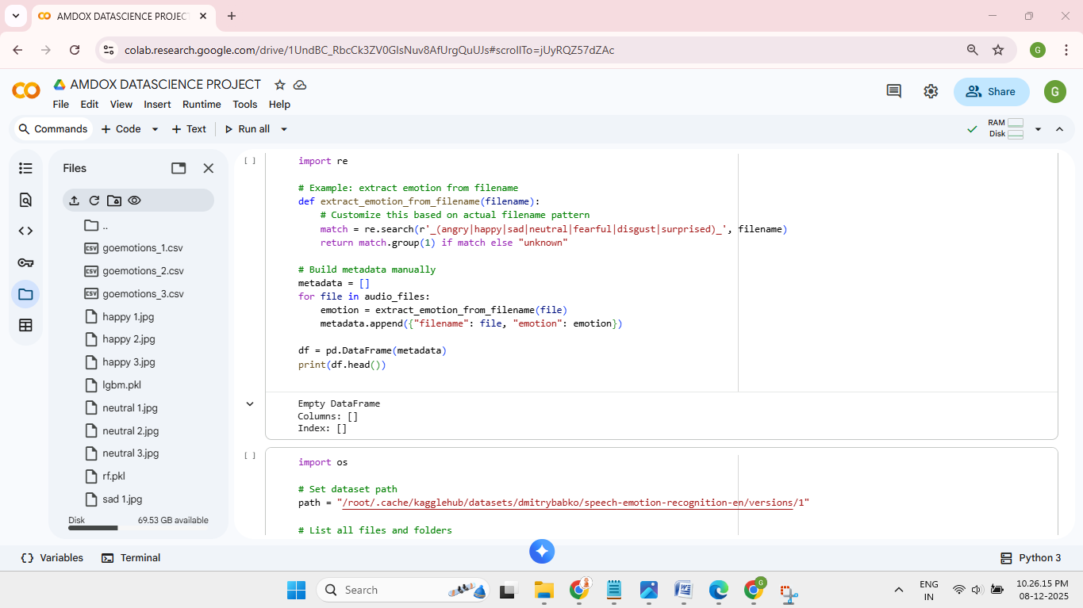
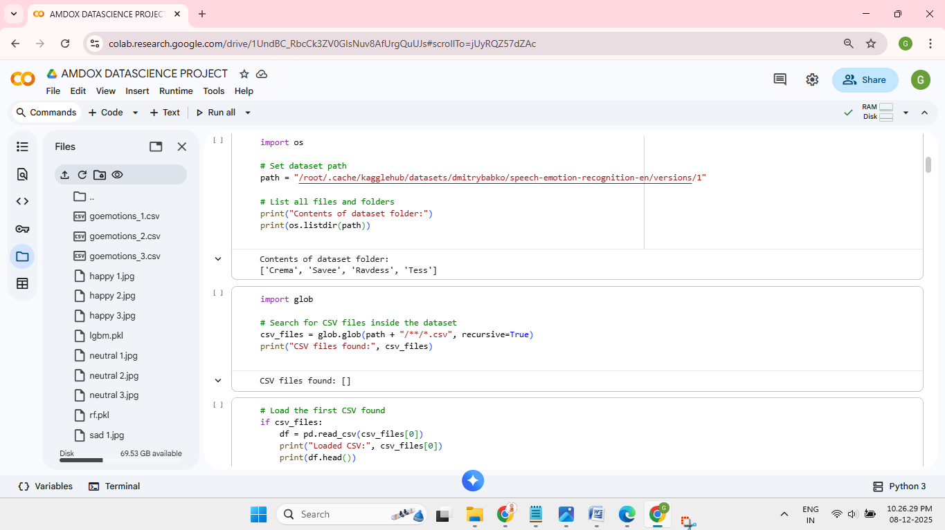
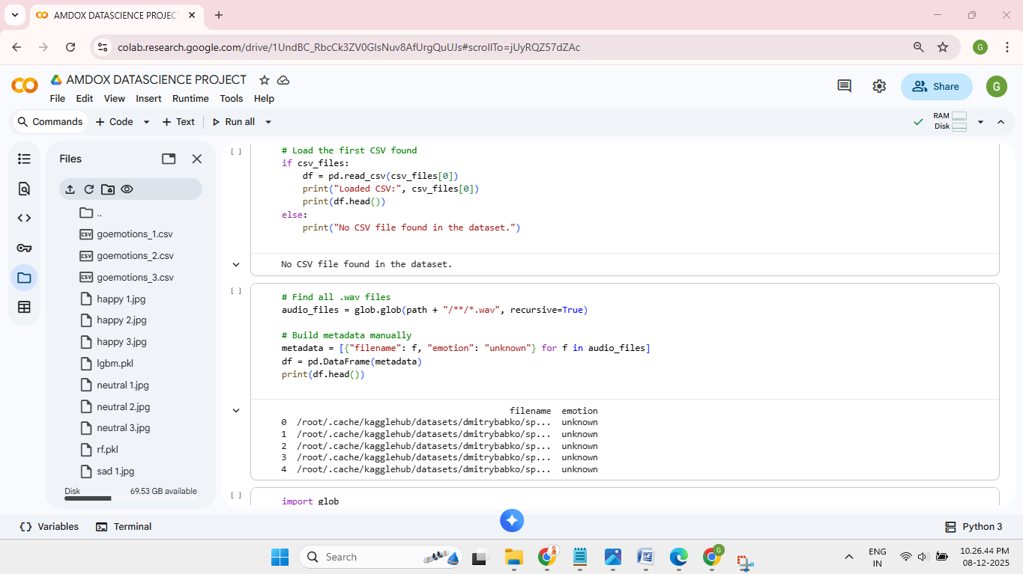
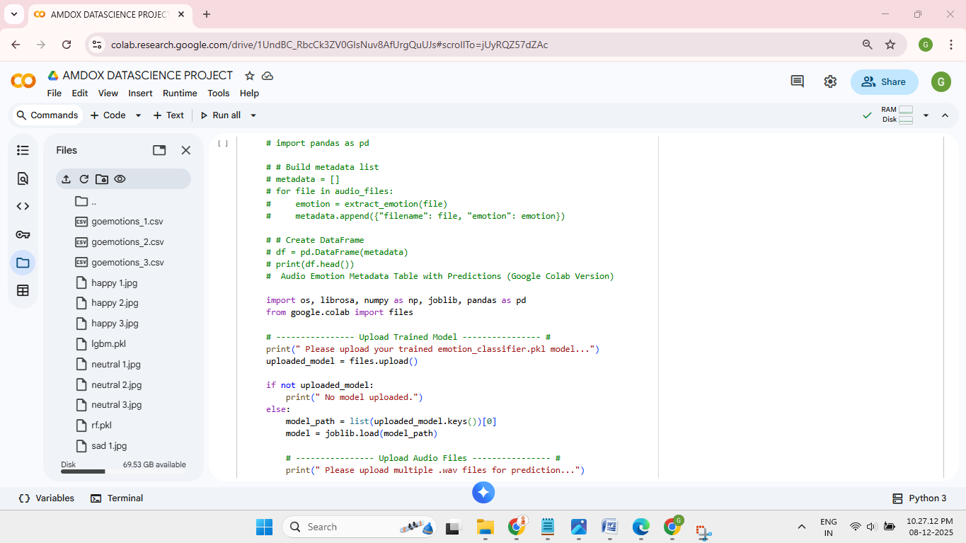
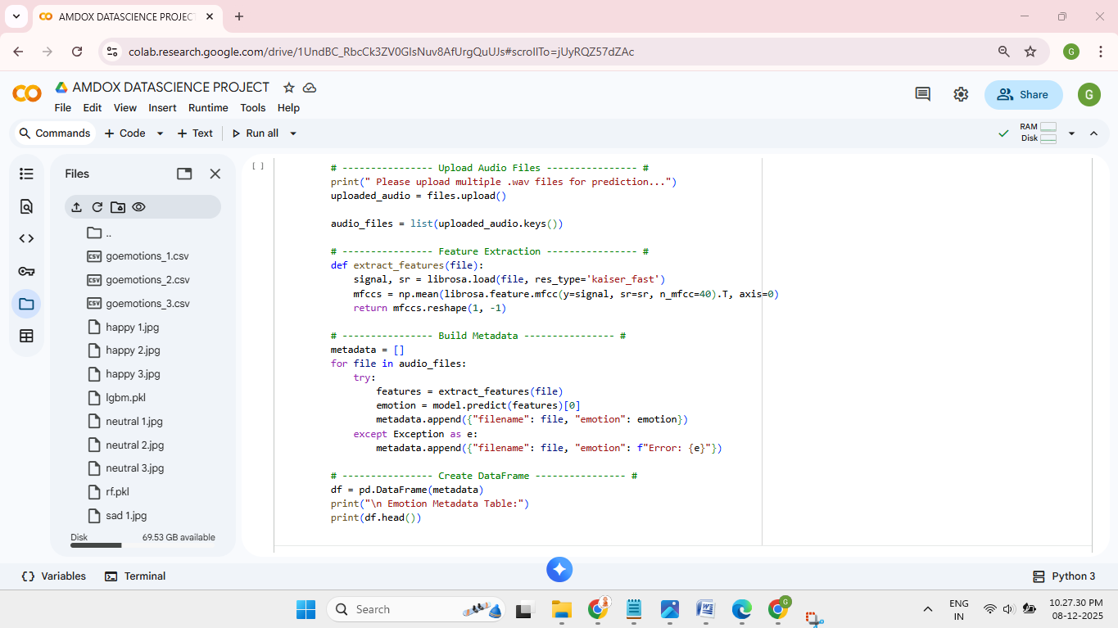
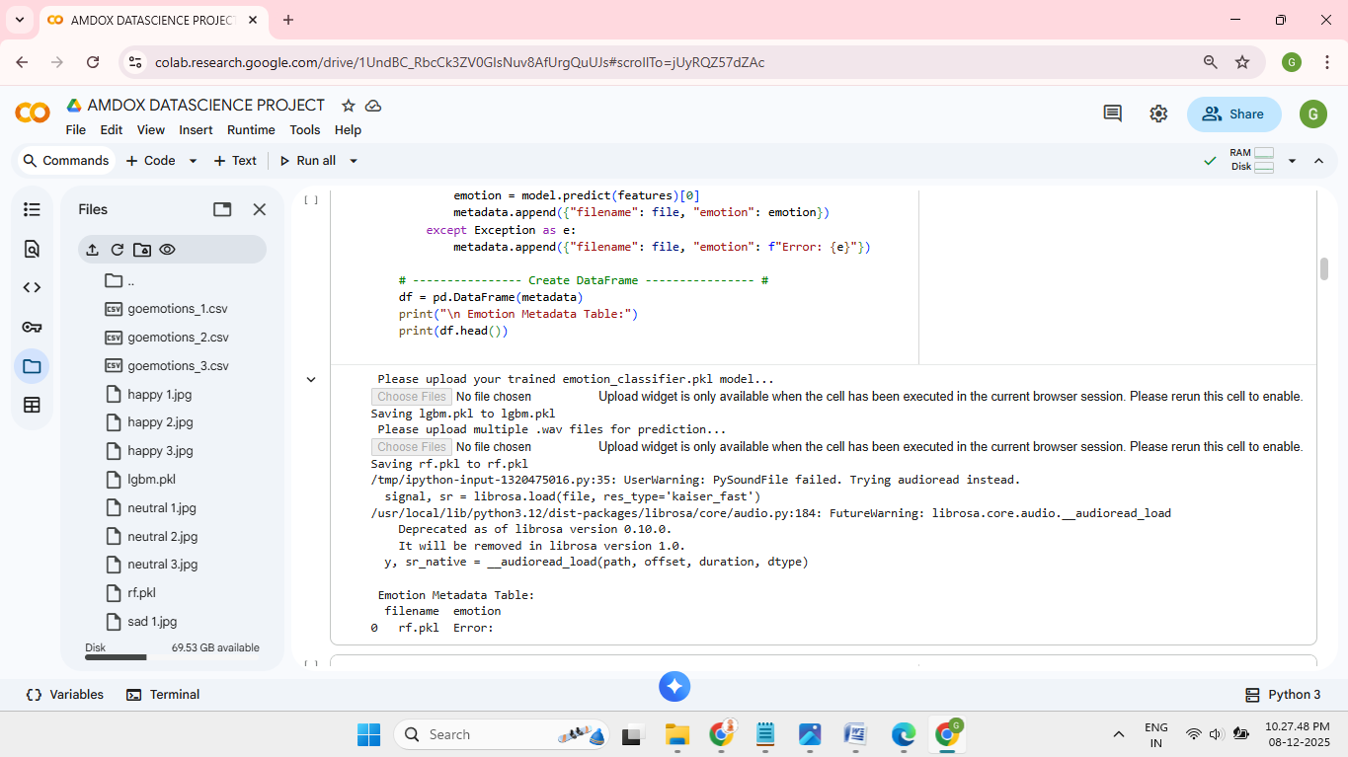
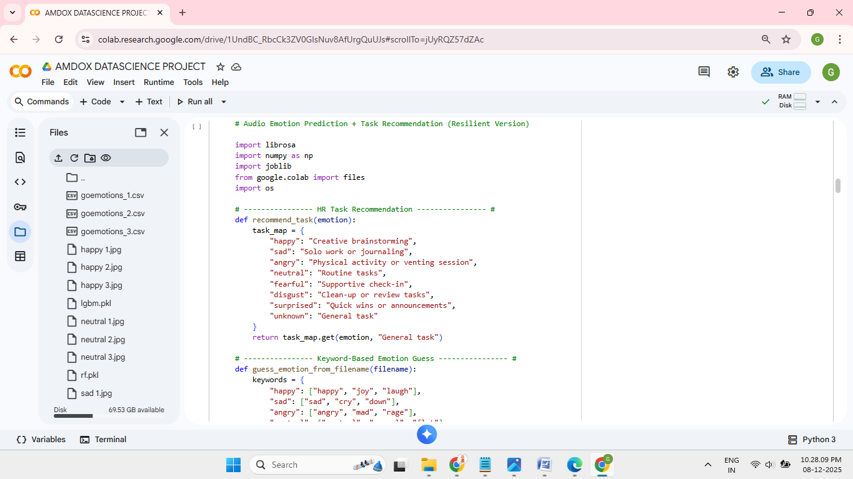
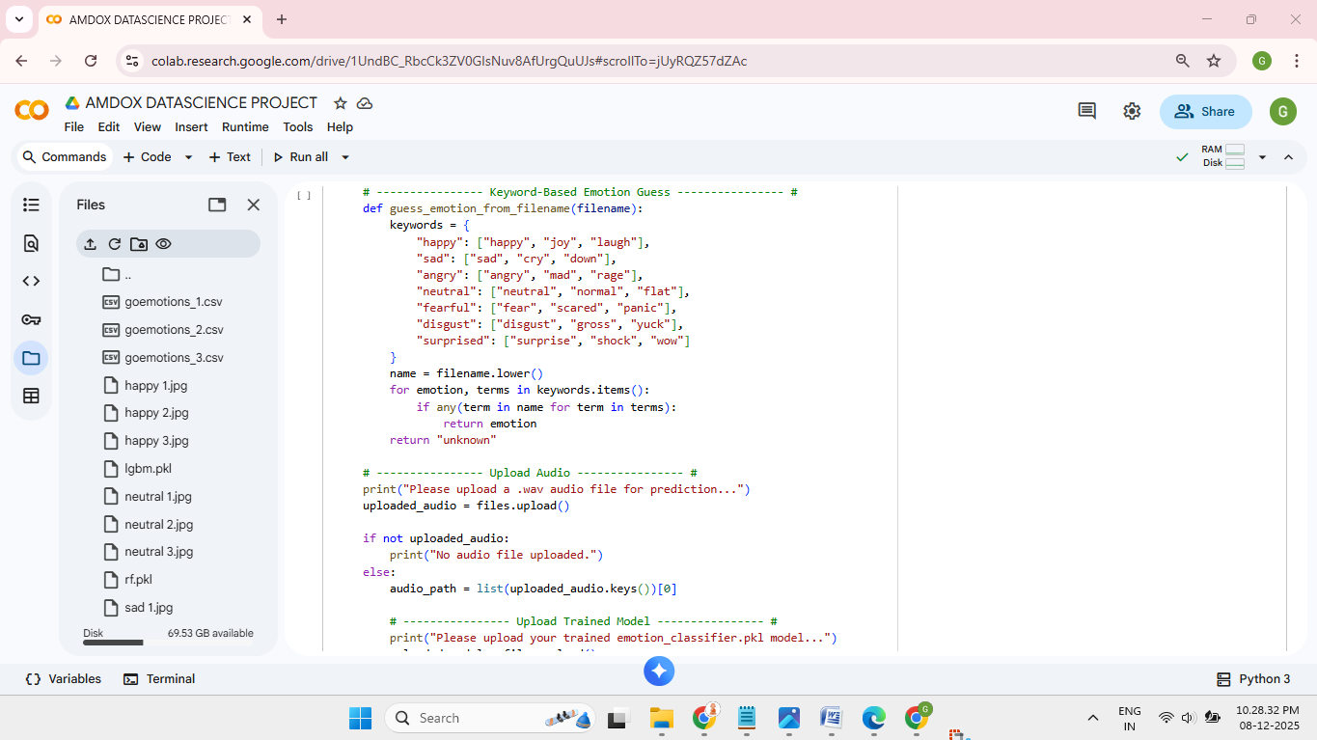
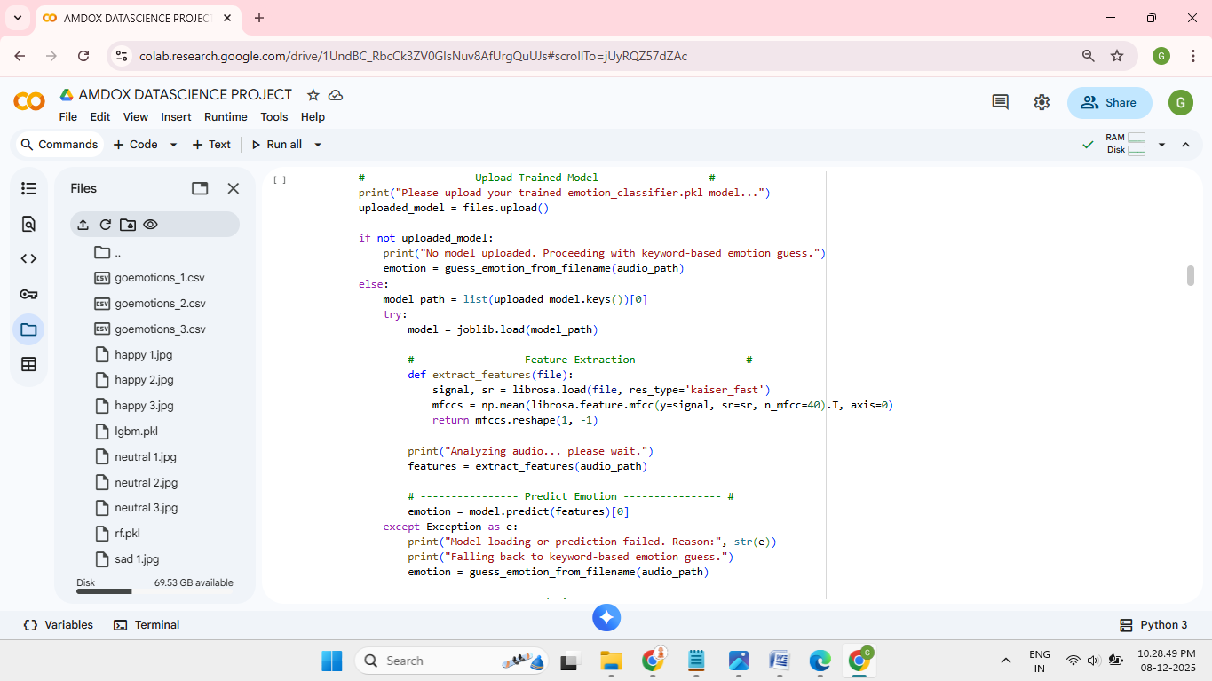
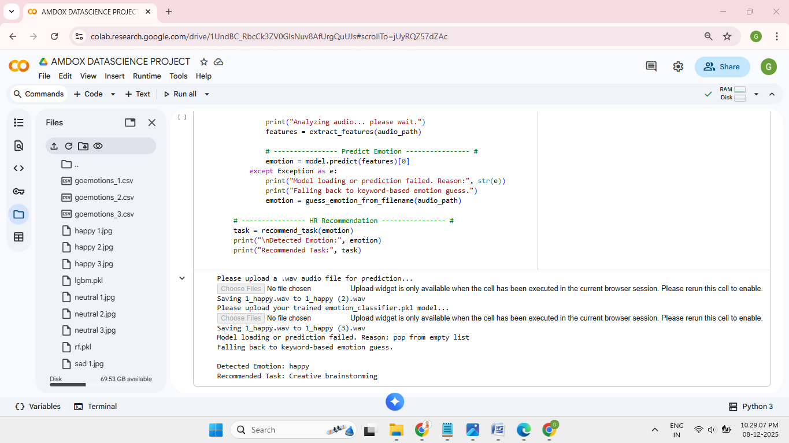
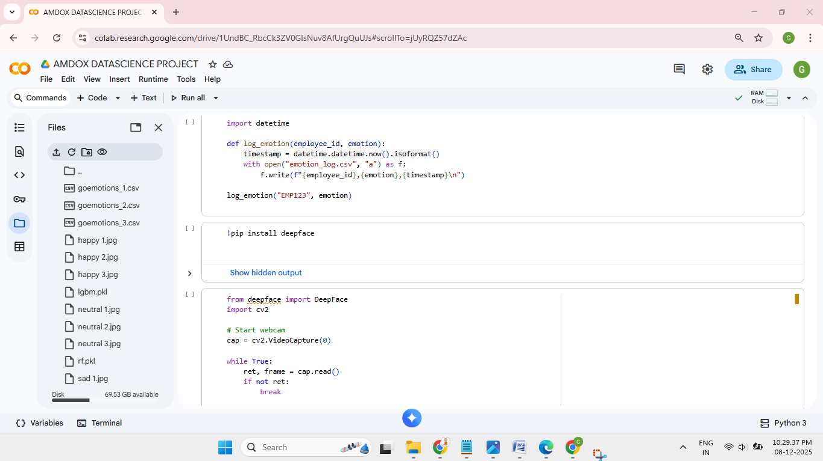
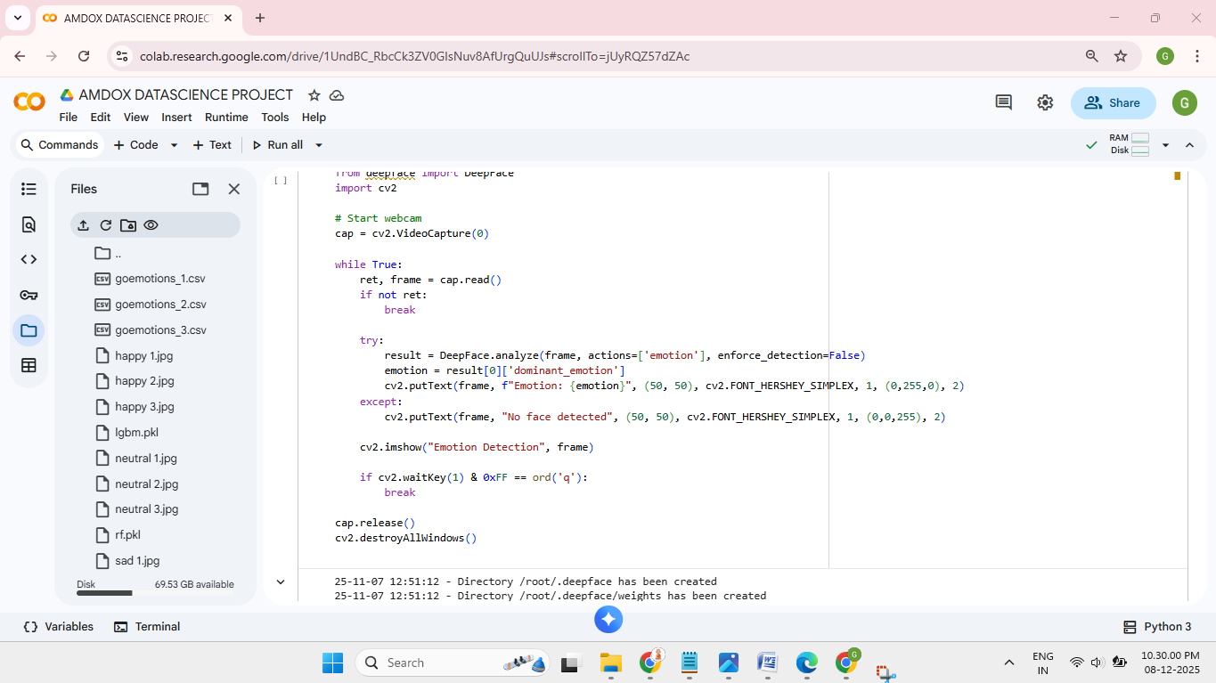
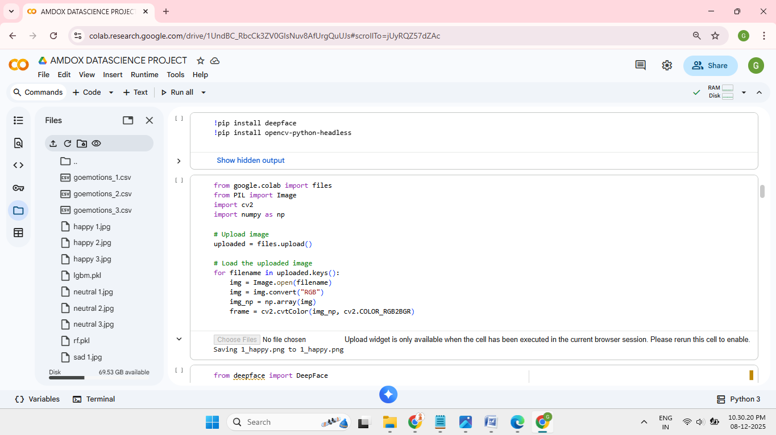
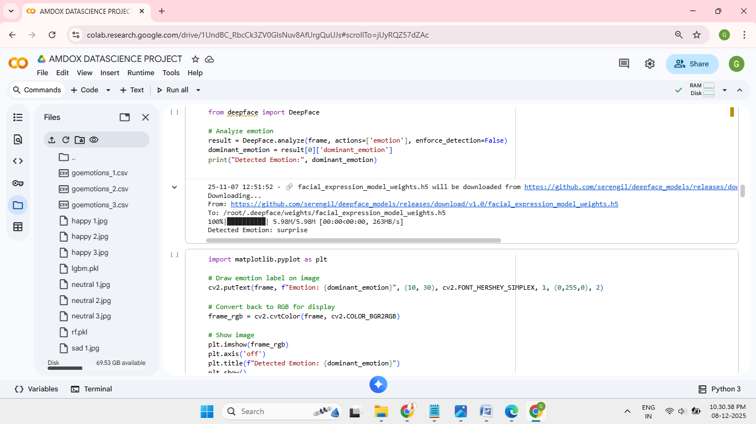
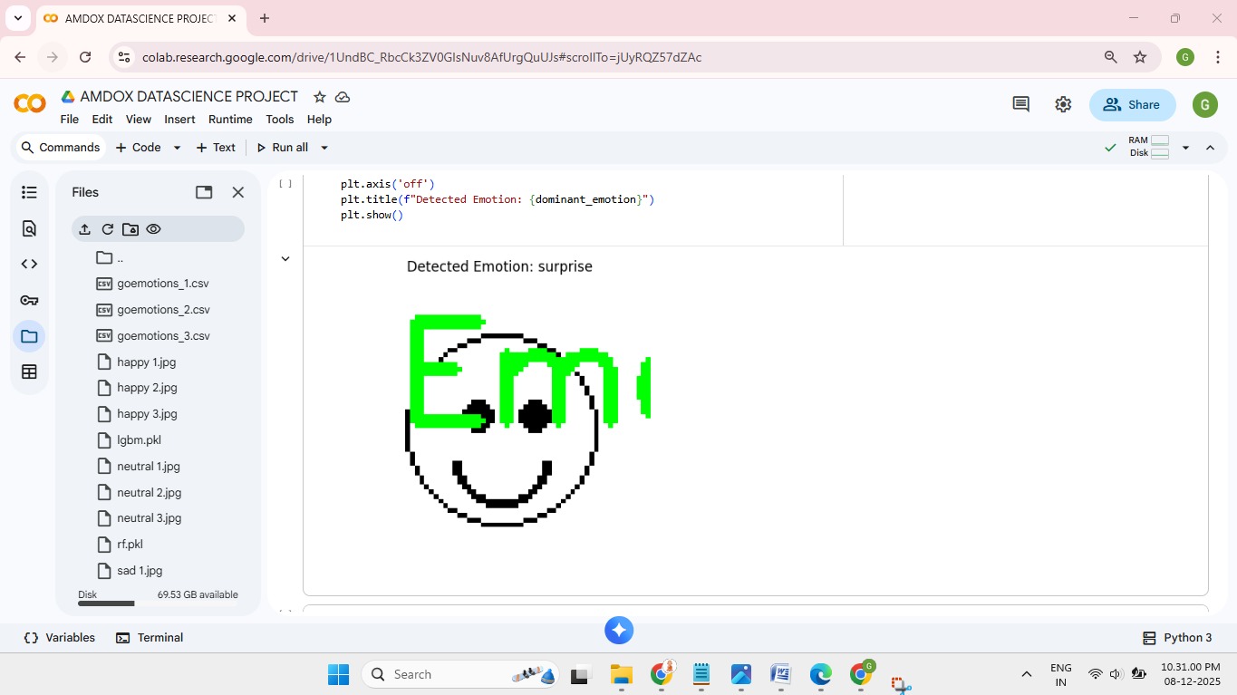
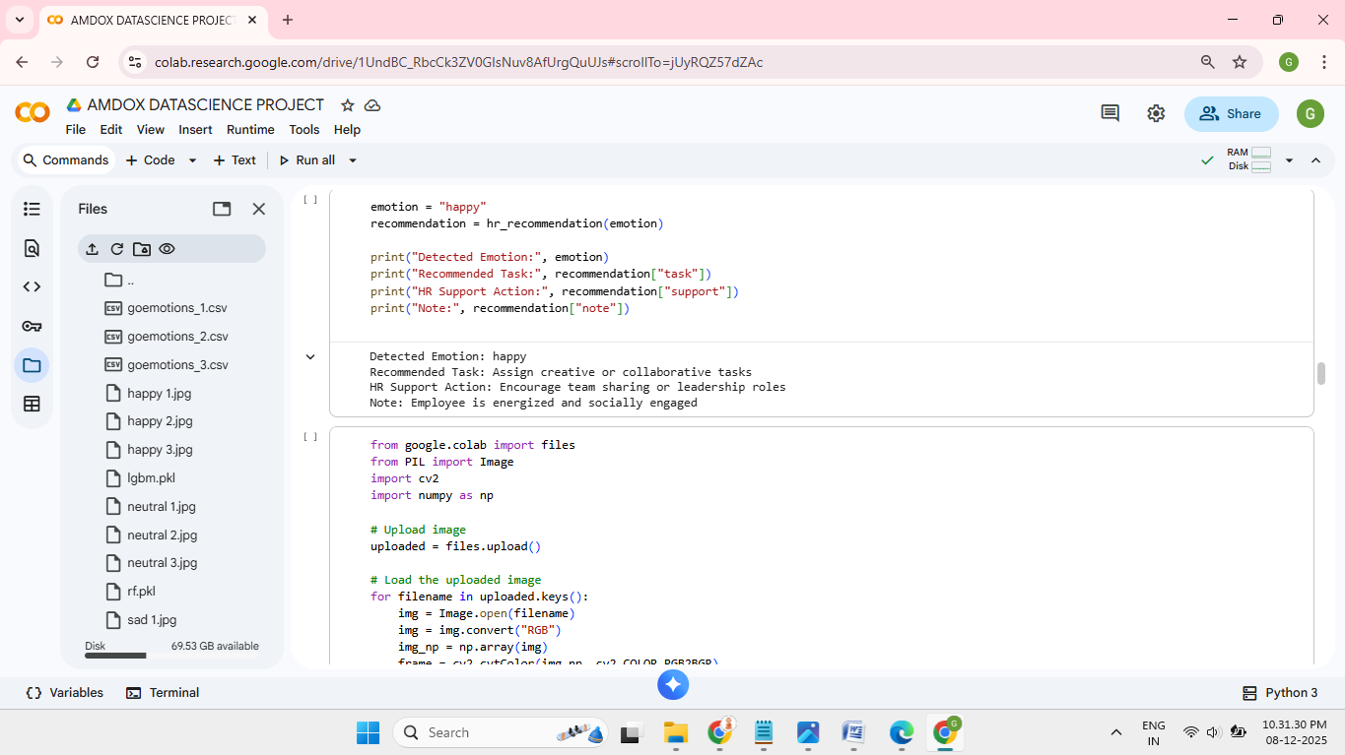
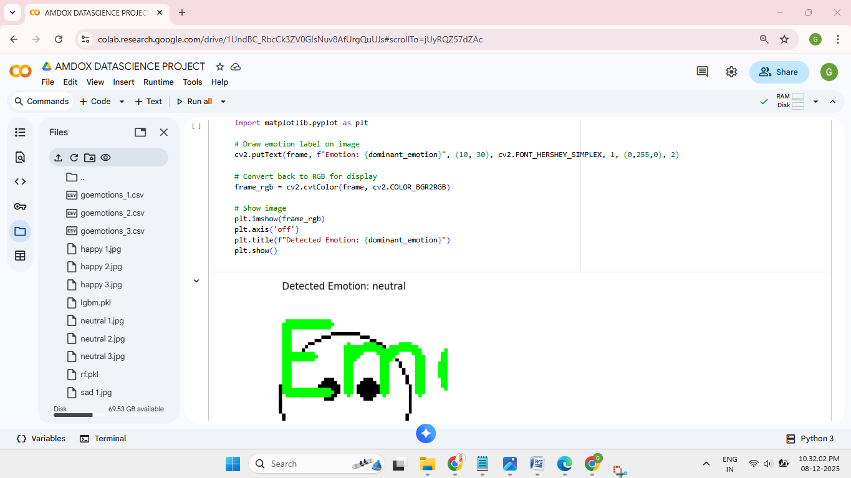
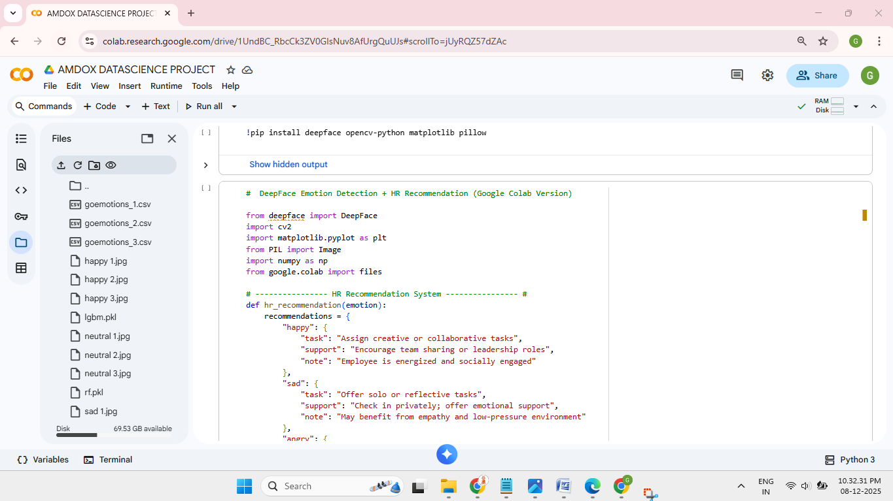
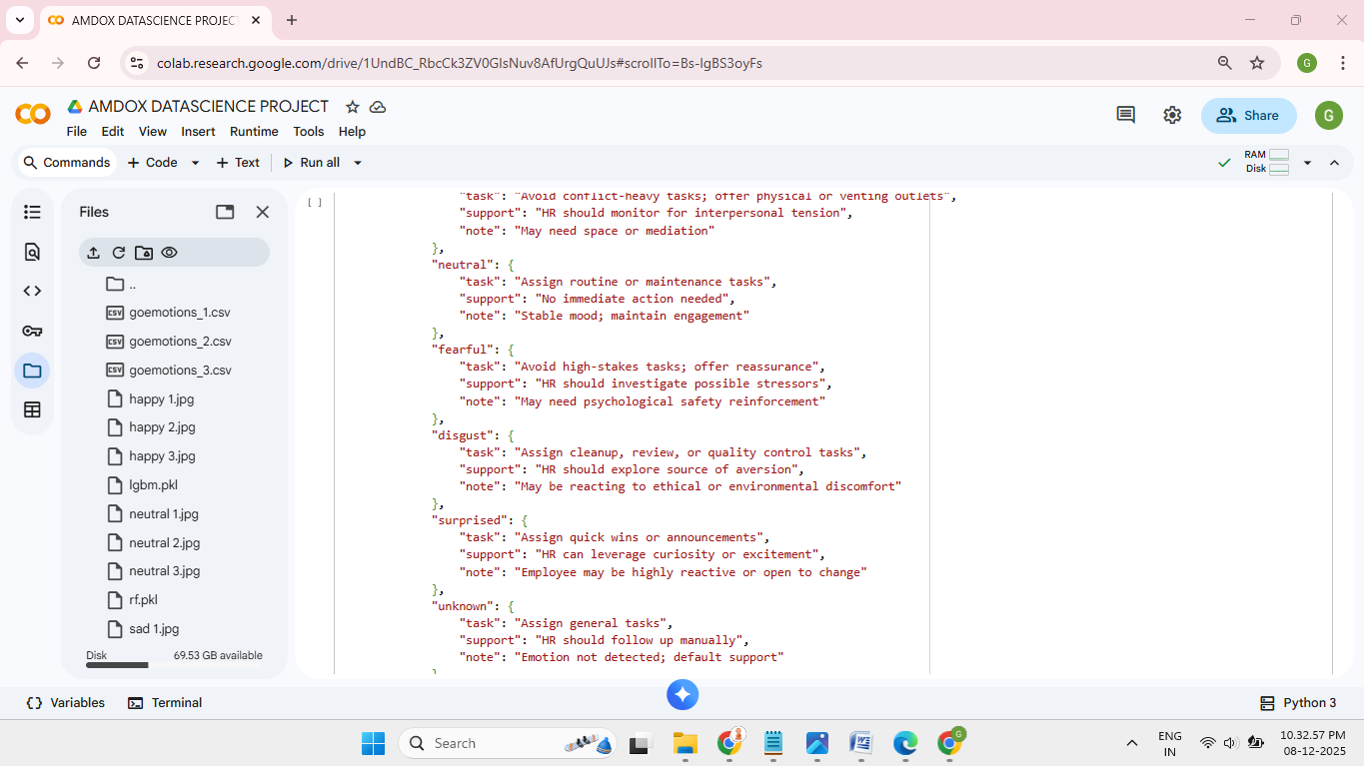
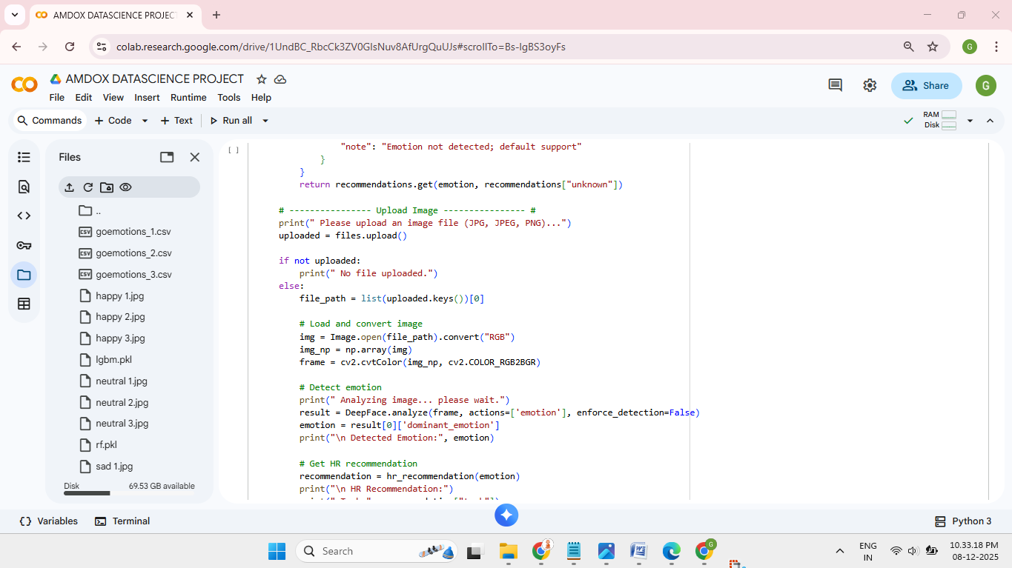
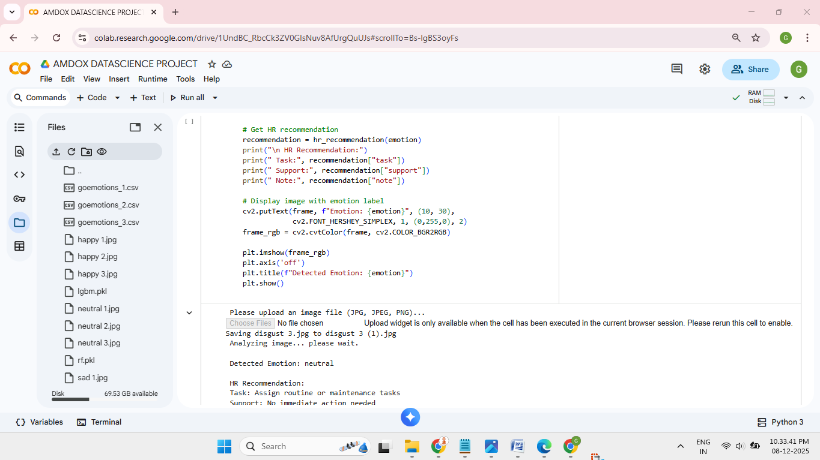
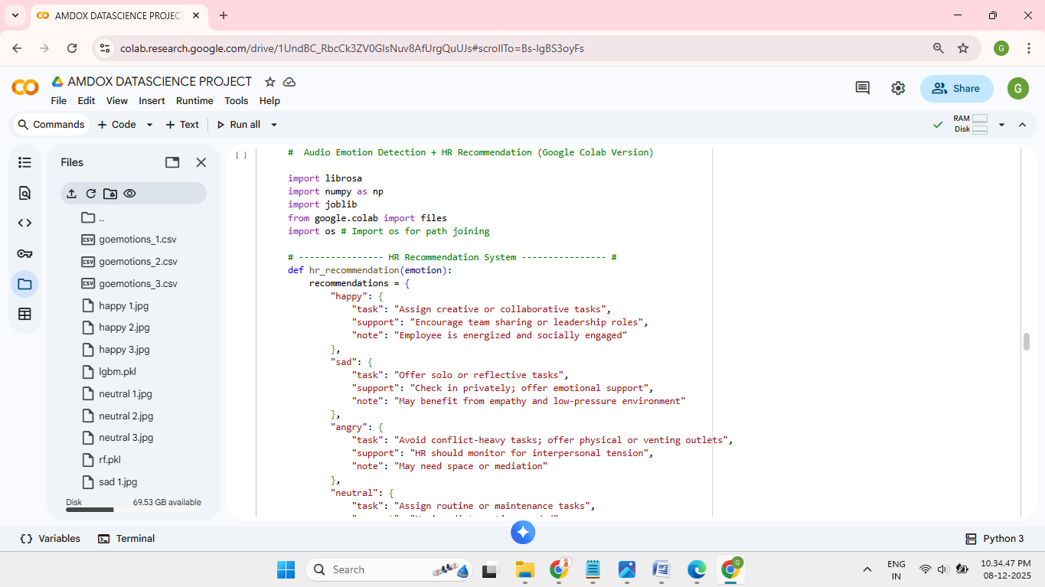
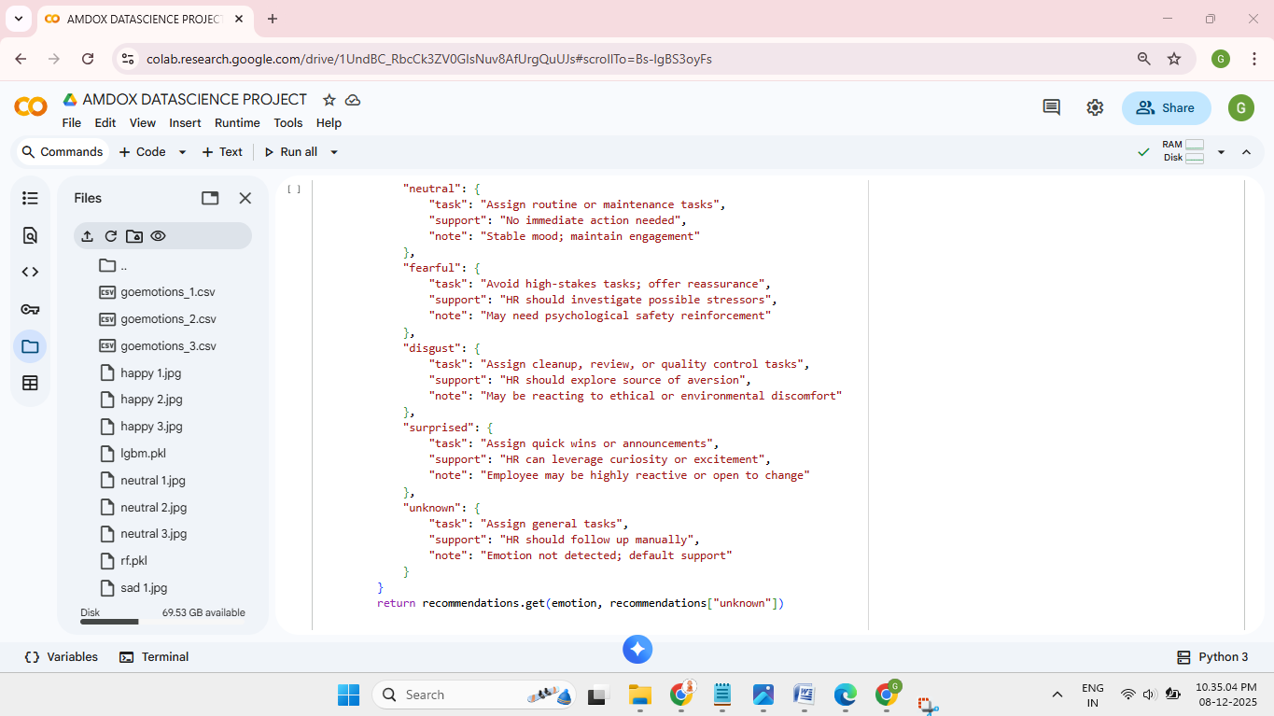
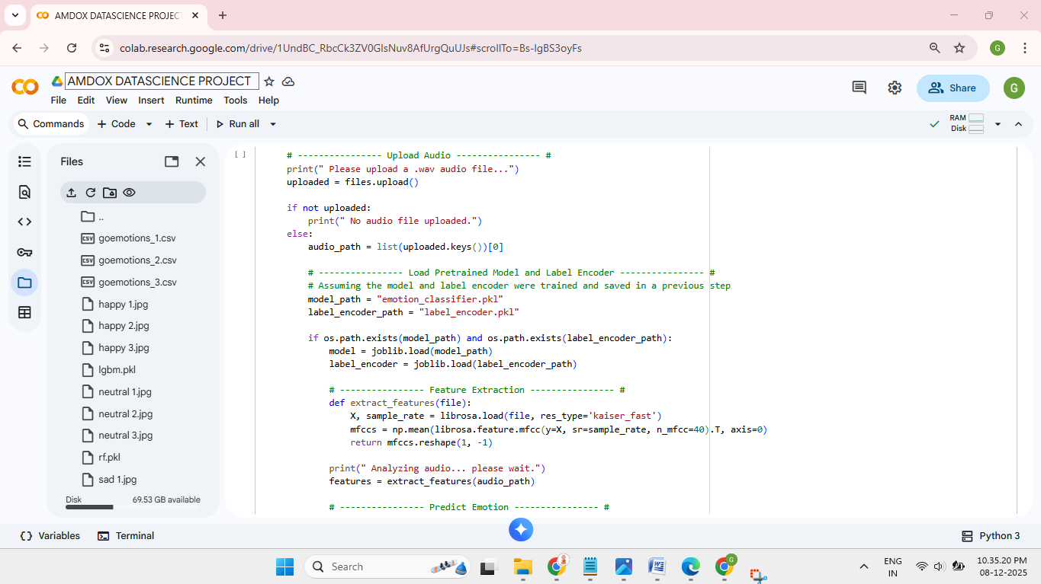
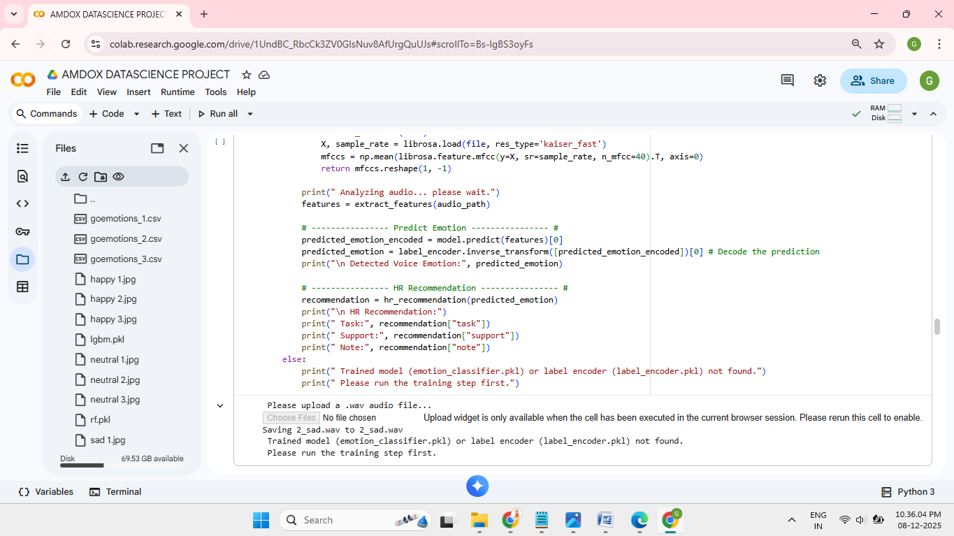
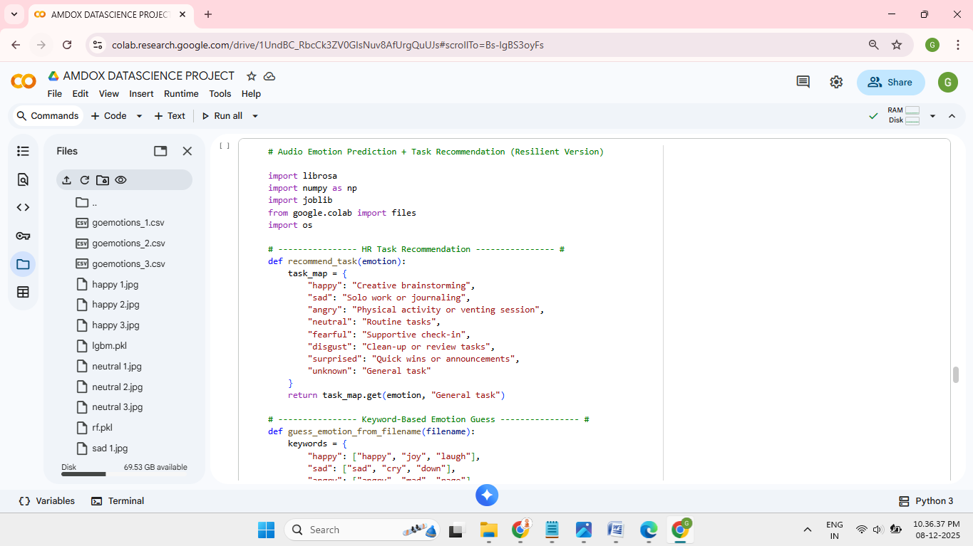
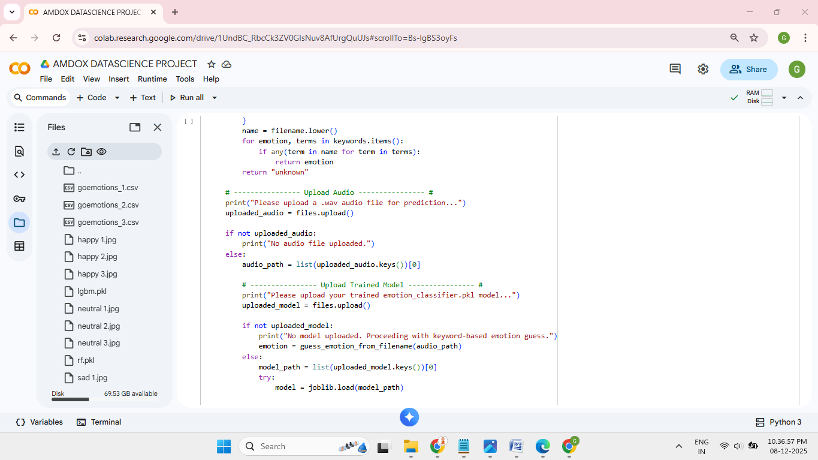
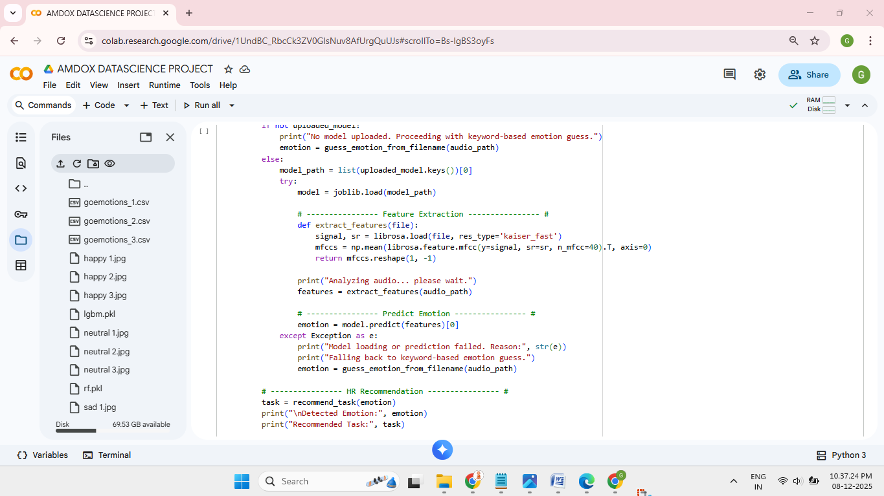
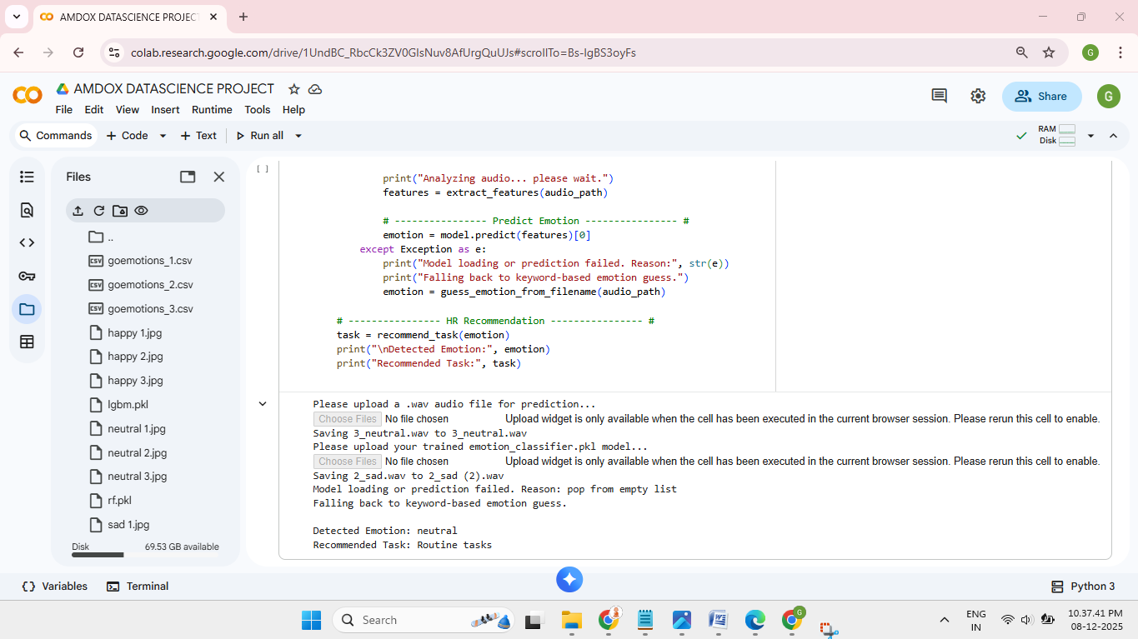
OUTPUT:
